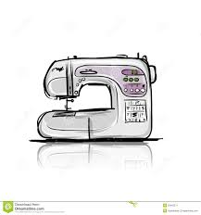Name____________________________________ period_______ day______

**SEWING MACHINE PARTS & SEWING TECHNIQUES**

Read each statement and **write the word** True if the statement True or **write the word** False if the statement is false.

**Do not write T’s or F’s. -1 for every T or F**

______________1. The hand wheel of the sewing machine is located on the left

side of the sewing machine.

______________2. The presser foot should be raised or in the up position when

threading the sewing machine.

______________3. The light will turn on when you turn the machine power

switch on.

______________4. The spool pin holds the bobbin.

______________5. When winding a bobbin you should keep the same steady

speed the whole time until the bobbin is complete.

______________6. The foot pedal is located on the floor.

______________7. The bobbin case is located on the top of the machine.

______________8. The thread cutter is located on the left side of the machine.

______________9. The sewing machine has a handle on top to carry it to

different locations.

_____________10. The bobbin case cover is located **under** the bobbin.